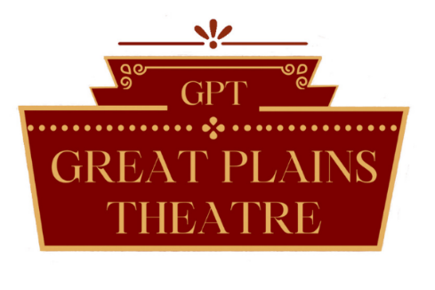

Great Plains Theatre
2024 Advertising Form

Great Plains Theatre’s advertising provides your company with an opportunity to benefit your company as well as give back to the region. GPT is a non-profit organization that depends on support from and gives back to its community and region.

Company/Business Name: ______________________________________________

Contact Name: ________________________________________________________

Phone Number: ________________________________________________________

E-mail Address: _______________________________________________________

Website (if applicable): __________________________________________________

Place a mark next to each of the advertising items that you are interested in purchasing as our advertising is based on what you chose and find beneficial for your company.

______ Full page Ad in Main Stage Season Playbills– All 5 shows- $750

______ Half page Adin Main Stage Season Playbills– All 5 shows - $500

______ Quarter page Ad in Main Stage Season Playbills– All 5 shows- $250

______ Website Ad – Logo and link on website - $1,200

______ Social Media Ad– Logo and verbiage on Facebook & Instagram - $1,000

______ Newsletter Ad – Logo and website link in newsletter- $750

All advertising options will need to be paid before inclusion of any advertising by GPT. Delays may cause advertising to be omitted and/or published.

Advertising that is accepted includes only digital formats such as .JPG, .TIFF, and .PDF. No other formats will be accepted. All content must be provided by the company/business as GPT does not create the content itself. This must be turned in before any advertising begins.

___________________________________ ____________________________________ ___________
Signature Printed Name Date
Great Plains Theatre Detailed Advertising Breakdown

Full page Ad in Main Stage Season Playbills
- Ad printed in 5 main stage show playbills –The Wedding Singer, Oliver!, Nunsense, Around the World in 80 Days, and Miracle on 34th Street
- Printed in full color
- Each show reaches an audience of 2,000total patrons which equivalates to 10,000 total patrons reached for all shows (not exact – estimate based on the last 5 years of shows)
- Full page ad = 5” X 7” printed image

Half page Ad in Main Stage Season Playbills
- All details listed above in “Full page in Main Stage Season Playbills” are included except size
- Half page ad = 5” X 3.5” printed image

Quarter page Ad in Main Stage Season Playbills
- All details listed above in “Full page in Main Stage Season Playbills” are included except size
- Quarter page ad = 2.5” X 3.5” printed image

Website Ad
- Ad will appear on bottom of home page of website (www.greatplainstheatre.com)
- Ad will appear in full color
- A link will be attached to the image itself to a website of your choosing
- Our website reaches approximately 1,900 visitors per month
- Will remain on website from date of purchase until December 31, 2023

Social Media Ad
- Ad will appear as a post on the Great Plains Theatre Facebook and Instagram pages
- Ad will appear in full color of the image provided and MUST also contain verbiage written by the business (no longer than 75 words) and submitted at time of purchase
- GPT has over 5,000 followers on Facebook and over 950 followers on Instagram
- GPT will post 12 times between date of purchase until December 31, 2023, at their own discretion

Newsletter Ad
- Ad will appear on bottom of Great Plains Theatre’s weekly newsletter
- Ad will appear in full color
- A link will be attached to the image itself to a website of your choosing
- Our newsletter reaches approximately 2,000 subscribers each week
- Will remain on newsletter each Wednesday from date of purchase until December 31, 2023

